Executive Board Annual Report 2021

Name of the Section/Network/Temporary Working Group:

ECREA DMM (Diaspora, Migration and the Media)

Management team:

Chair: Sara Marino
Vice-chair: Silvia Almenara Niebla
Vice-chair: Maialen Goirizelaia Altuna

Number of members:

209
On Facebook: 583 members
On Twitter: 394 followers

Social media:

FACEBOOK: ECREA Diaspora Migration Section
Twitter: @ecreadmm

Activities in 2021:
Word limit: 250 words
- April 21-23, 2021. Conference Migrant Belongings. Digital practices and the everyday (https://migrantbelongings.sites.uu.nl/). Co-organized with Sandra Ponzanesi as part of the ERC project CONNECTINGEUROPE, Digital Crossings in Europe: Gender, Diaspora and Belonging.
The conference included five keynotes by Engin Isin (Queen Mary University of London), Nicholas de Genova (University of Houston), Larrisa Hjorth (RMIT University), Saskia Witteborn (Chinese University of Hong Kong) and Paul Gilroy (University College London). The keynotes were visually harvested by Renée van den Kerkhoven (neetje.nl) as shown by the example below.
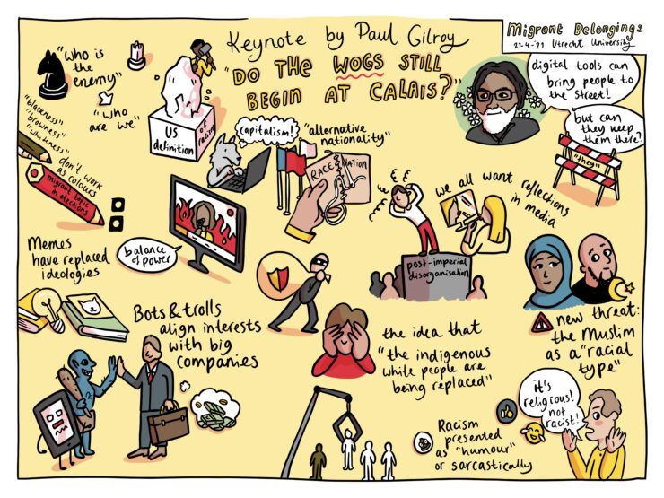
Alongside the five keynotes, more than two hundred participants presented their latest research findings and insights during 34 different panels, over the course of 8 parallel sessions. A PhD workshop for young researchers was held, facilitated by Nishant Shah (ArtEz University of the Arts, Arnhem) and Saskia Witteborn. Finally, special roundtable sessions where held, including a film screening of Bab Sebta and Q&A with the filmmaker Randa Maroufi, supported by the Reell borders’ ERC STG project. There was also a discussion between community workers of the Utrecht-based De Voorkamer and media makers including Shaker Productions.
A selection of the proceedings from the conference will be published in a special issue of the journal Communication, Culture & Critique, and the anthology Doing Digital Migration Studies, under contract with Amsterdam University Press.
- September 6-9, 2021. ECREA Braga conference. ECREA DMM section hosted 10 panel sessions.
- Diaspora, creative practices & performativity
- Media practices
- Histories, memories and research practices
- Identities
- Discourses and meaning making
- Intersectionality and difference
- Handbook of media and migration launch 1
- Handbook of media and migration launch 2
- Representing difference
- The techno-politics of migration

Plans for 2022:
Word limit: 250 words
Our first objective is to further deconstruct the eurocentric approach in media and diaspora studies by continuing the work and research done by the previous and current management teams around the most urgent issues of our time affecting communities and individuals across and despite of borders.
The second objective we have is to actively support and encourage the decolonization of media and diapora studies by opening up our section to a more diverse range of voices including refugee voice and the voices of indigenous communities in areas such as latin america, which are too often neglected.
To respond to our objectives, we would like to propose some ideas for potential conference themes. one idea we hope to consolidate is the topics of diaspora diplomacy and the importance of diasporas as public diplomacy agents and the digital humanitarianism and grassroot solidarity across borders. Finally, we hope to continue and strengthen the section’s already consolidated research on the topics of borders and media, by actively encouraging the participation of a more diverse range of speakers, by encouraging the proposition of new methodologies of research and by strengthening our ethical commitments.

